Multiple-choice section – choose the correct answer

Question 1 [12.1]

Which of the following is not a linear equation?

A y = x2 + 3 B 1 = C 2y = 7x – 4 D y = 4 − x

Question 2 [12.4] [10A]

When simplified, the value of  is:

A 72 B 26 C 18 D 6

Question 3 [12.3]

8x4 × 2x6 simplifies to:

A 16x24 B 40x8 C 16x10 D 10x10

Question 4 [12.3]

When simplified, (4x6)3 is equivalent to:

A 12x9 B 8x9 C 64x9 D 64x18

Question 5 [12.5] [10A]

The value of (32) is:

A 5 B 10 C 16 D 64

Question 6 [12.5] [10A]

The value of  is:

A 0.5 B -5 C 2 D -2

Question 7 [12.1]

The horizontal asymptote of the graph of  is:

A x = 3 B y = 5 C y = 0 D y = 3

Question 8 [12.2]

The graph of  is:  
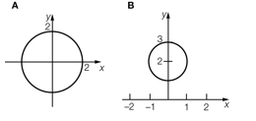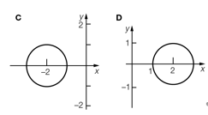

Multiple-choice results: ___ / 8

Short answer section

Question 10 2 marks [12.5] [10A]

Choose from the following words to complete the sentences below.

base coefficient index irrational number power surd

In the term 5x6, the ‘6’ is known as the _______________ or _________ of x.

Question 11 1 mark [12.5] [10A]

Complete the following sentence.

(243) = 5 because ______________________________________________________

Question 12 2 marks [12.4] [10A]

Simplify .

Question 13 2 marks [12.3]

Express 6a2b5 with positive indices.

Question 14 2 marks [12.3]

Write (x2y4)3 in in simplified form expressing your answer with positive indices.

Question 15 6 marks [12.5] [10A]

Simplify:

(a) (32) + (2) (b) (252) – (7) (c) 2

Question 16 6 marks [12.2]

(a) Write the equation formed if the circle with the equation x2 + y2 = 4 is translated 2 units right  
and 1 unit up.

(b) What is the centre of the transformed equation?

(c) What is the radius of the transformed equation?

(d) Sketch the graph of the transformed equation.

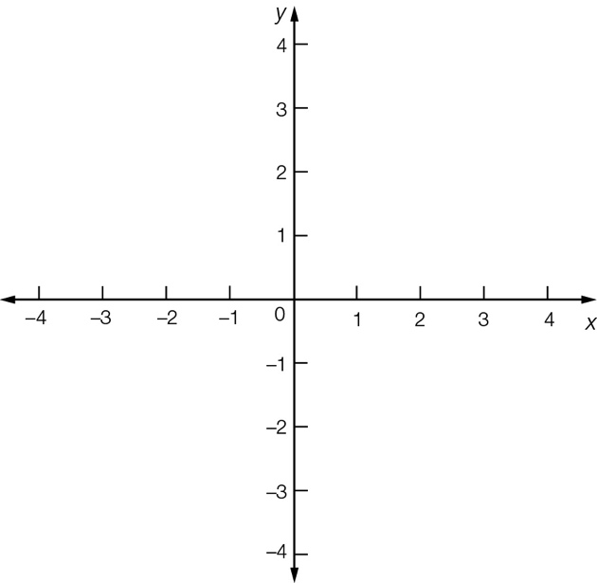

Question 17 4 marks [12.2]

(a) Write the new equation formed when the exponential graph with equation y = 4x is translated  
2 units right and 1 unit up.

(b) Sketch the graph of the transformed equation.

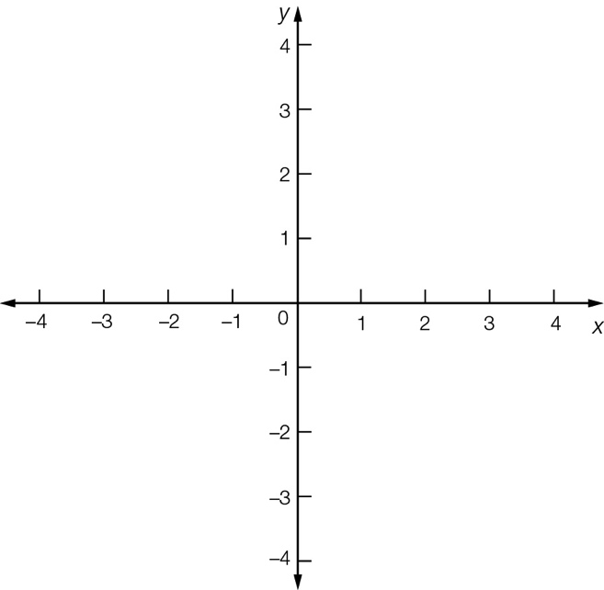

Question 18 6 marks [12.2]

(a) Write the equation formed if the graph with equation y =  is translated 3 units right and 1 unit up.

(b) What is the value of the horizontal asymptote?

(c) What is the value of the vertical asymptote?

(d) Sketch the graph of the transformed equation clearly showing the x- and y-intercepts.

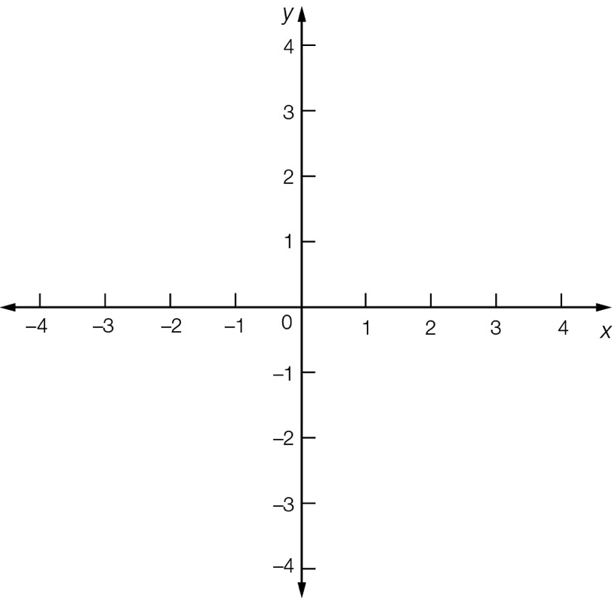

Short answer total:_____ /31

Extended answer section

Question 19 8 marks [12.1, 12.2]

(a) Write the equation of a circle with a centre at at (-3, 1) and radius 2 units.

(b) Plot the graph of this circle showing all relevant points.

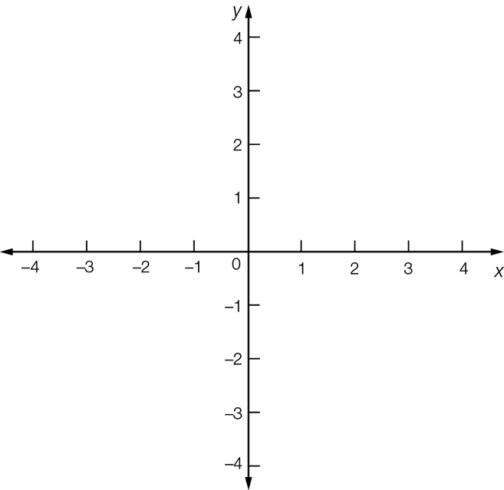

(c) What is the new equation formed if this circle has its radius increased by 1 unit.

(d) Sketch the graph of this circle.



(e) The graph in (d) is reflected in the x-axis. State the centre and the radius of this circle.

Question 20 8 marks [12.2]

When heated slowly, the temperature T °C of a vintage clothes iron increases according to the exponential rule , where t is the time in minutes.

(a) What is the initial temperature of the vintage clothes iron?

(b) What is the temperature of the vintage clothes iron after 3 minutes?

(c) Use the information from (a) and (b) to help you sketch the graph of .

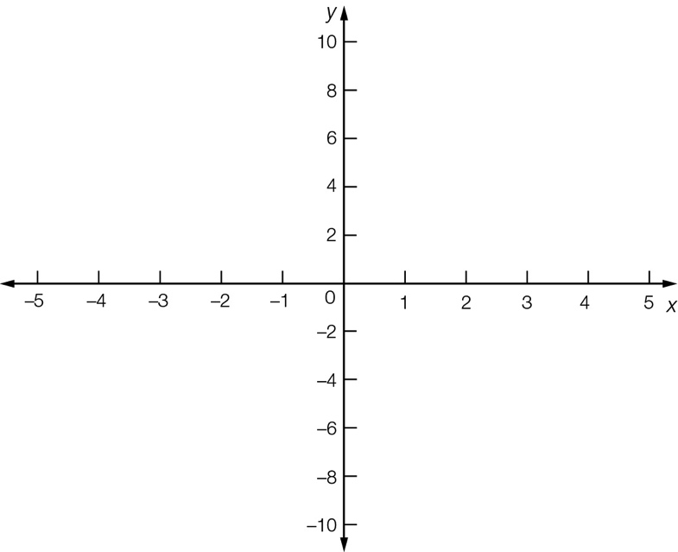

(d) Show that after 4 minutes the temperature of the vintage clothes iron will be 80 °C more than its initial temperature.

Extended answer total:____ /16

TOTAL test results: ____ / 55